**Arizona State University  
IFT 458**

Module 5, Assignment 2:

User Authentication

**Student**

Chih-Chieh Chang

**Professor**

Dinesh Sthapit

November 4, 2022

**Project: 1-User-Start**

* Created 5 users with textpassword

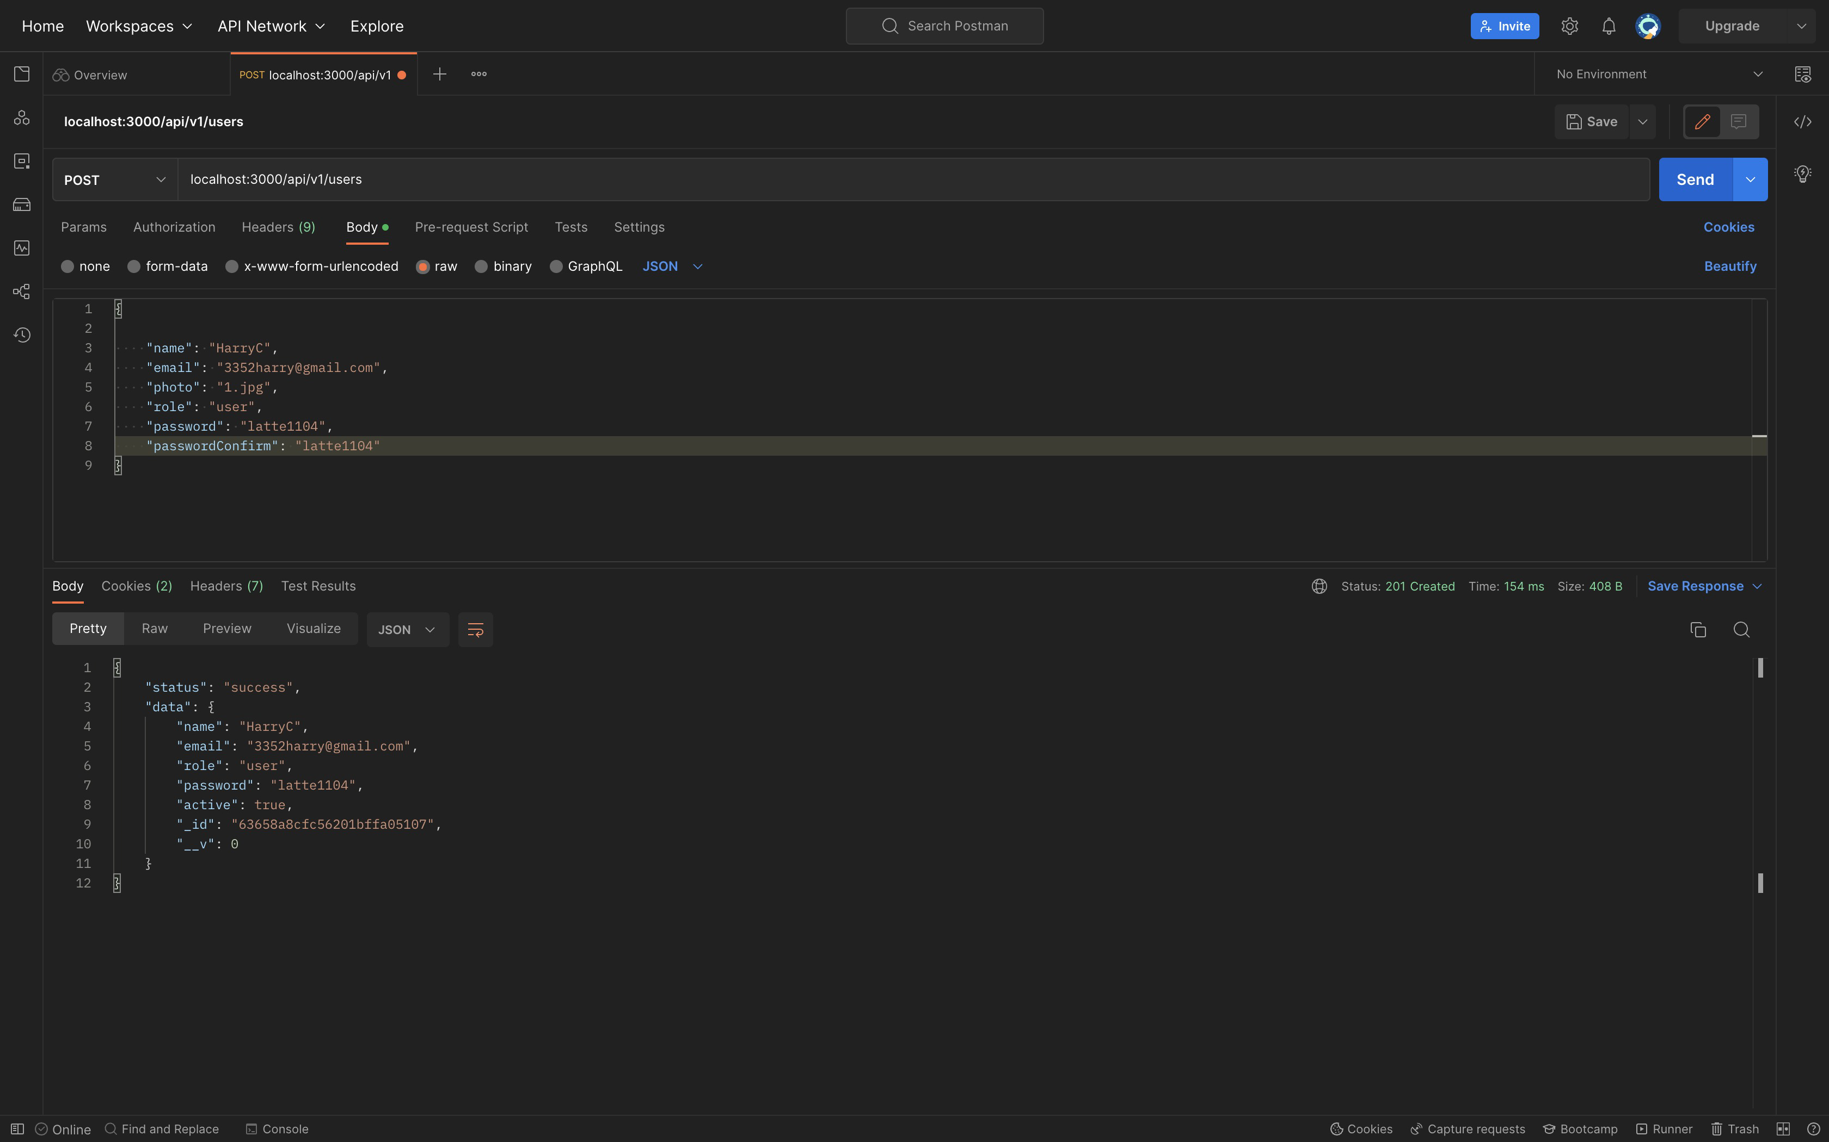

* MongoDB

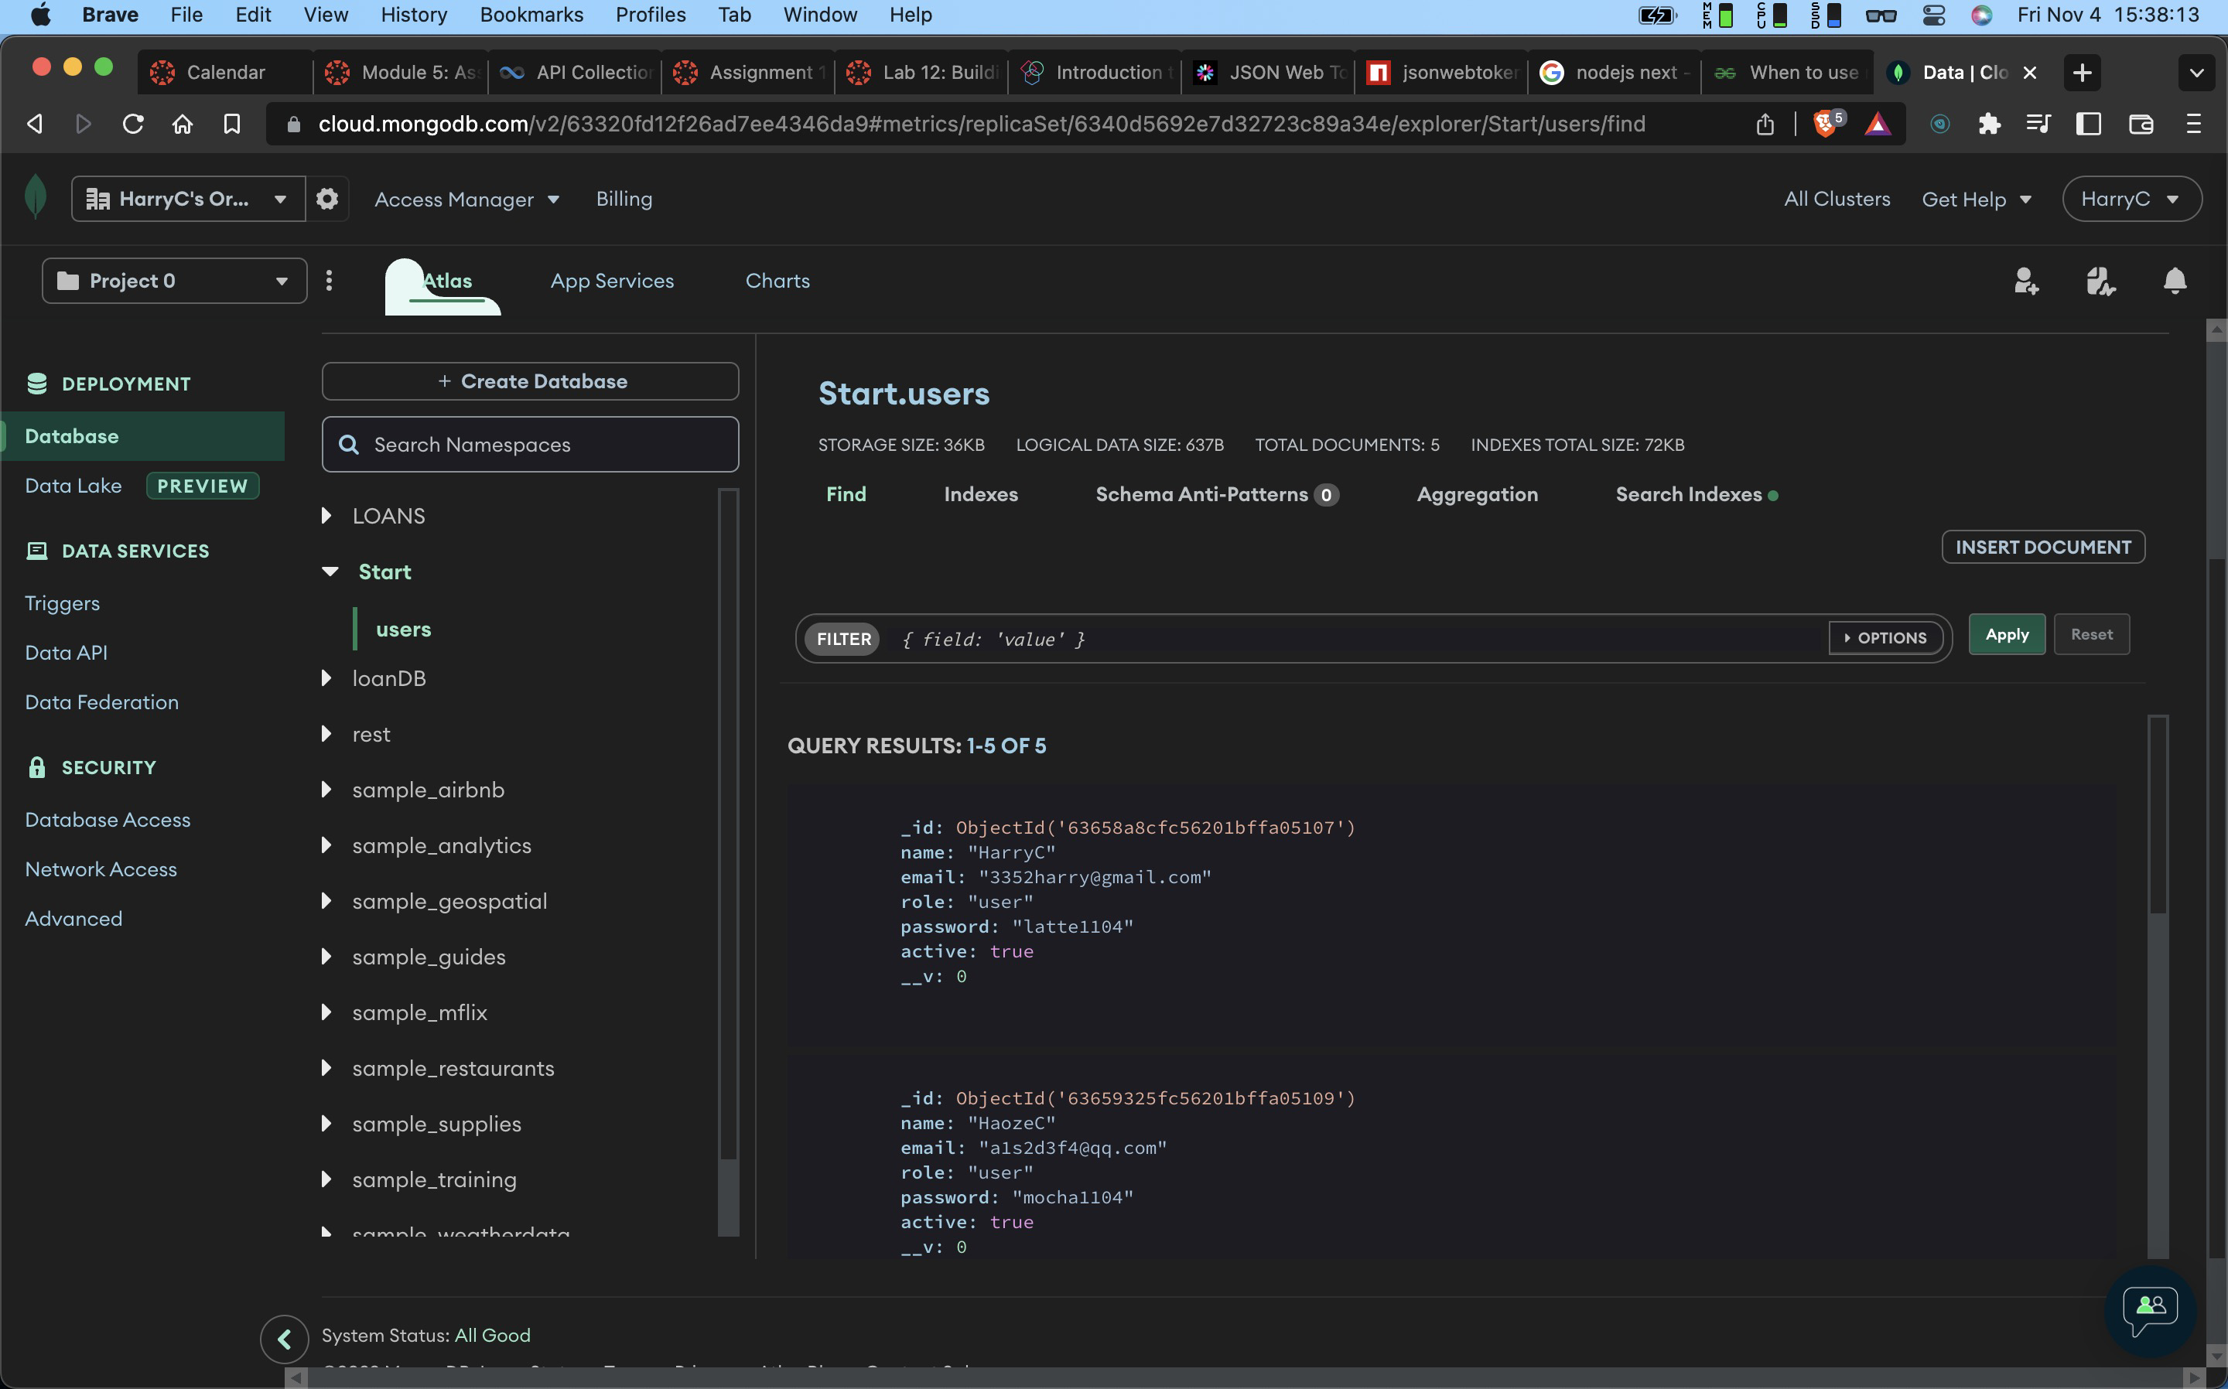

* Config.env

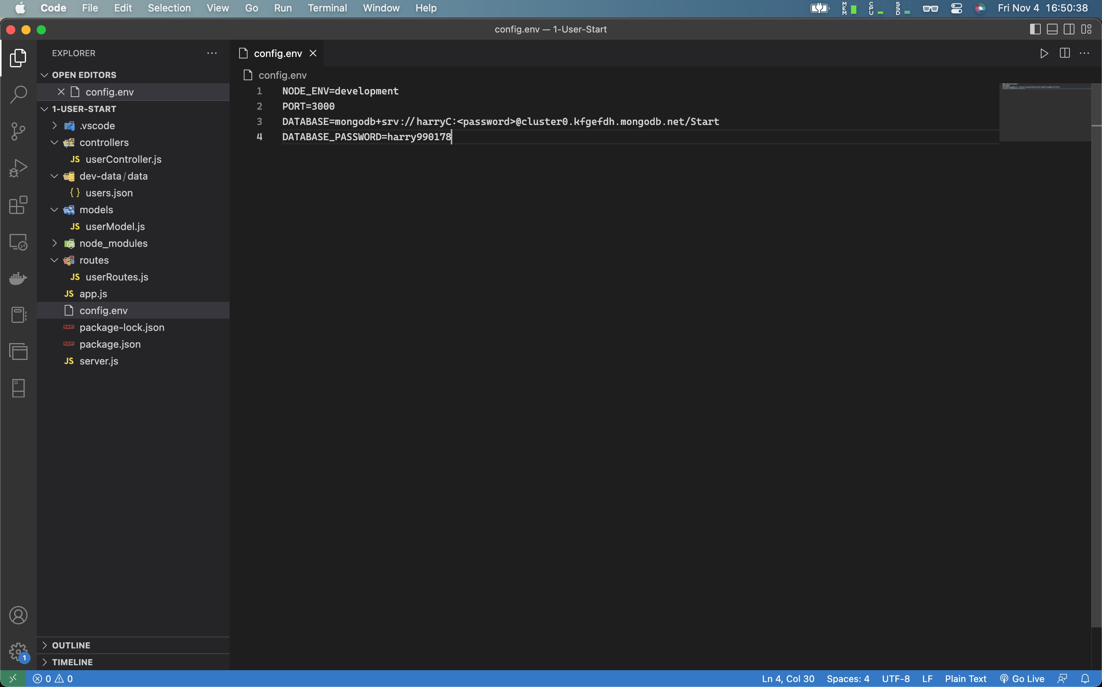

**Project: 2-User-encryption**

* Created 5 users with encrypted password

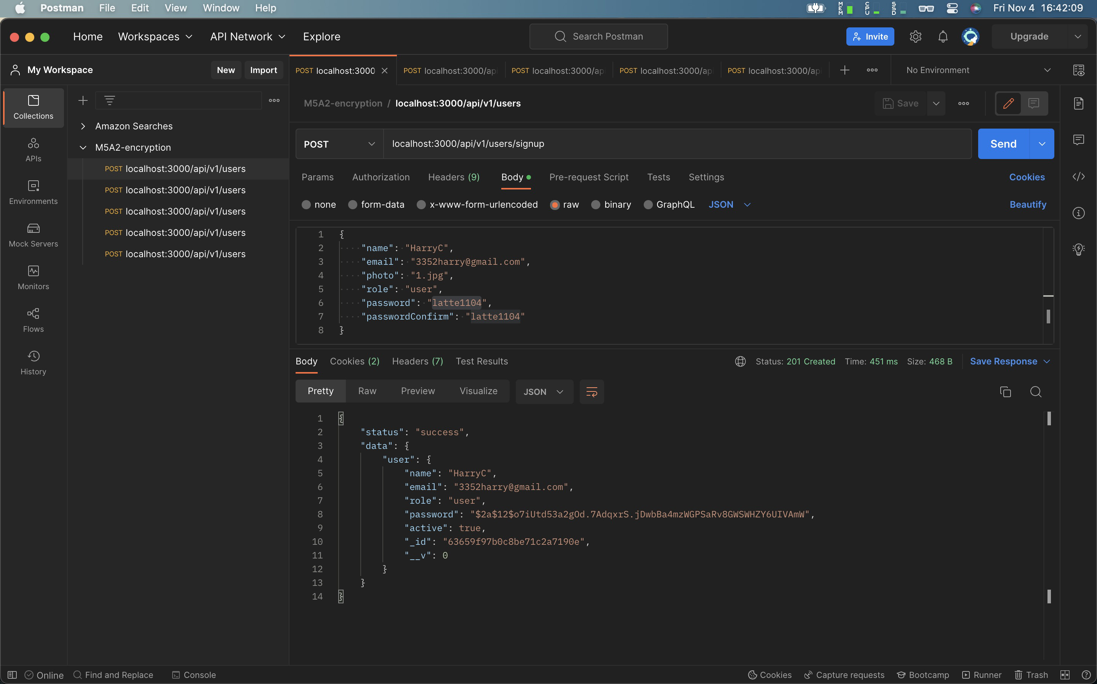

* MongoDB and decode the encrypted password

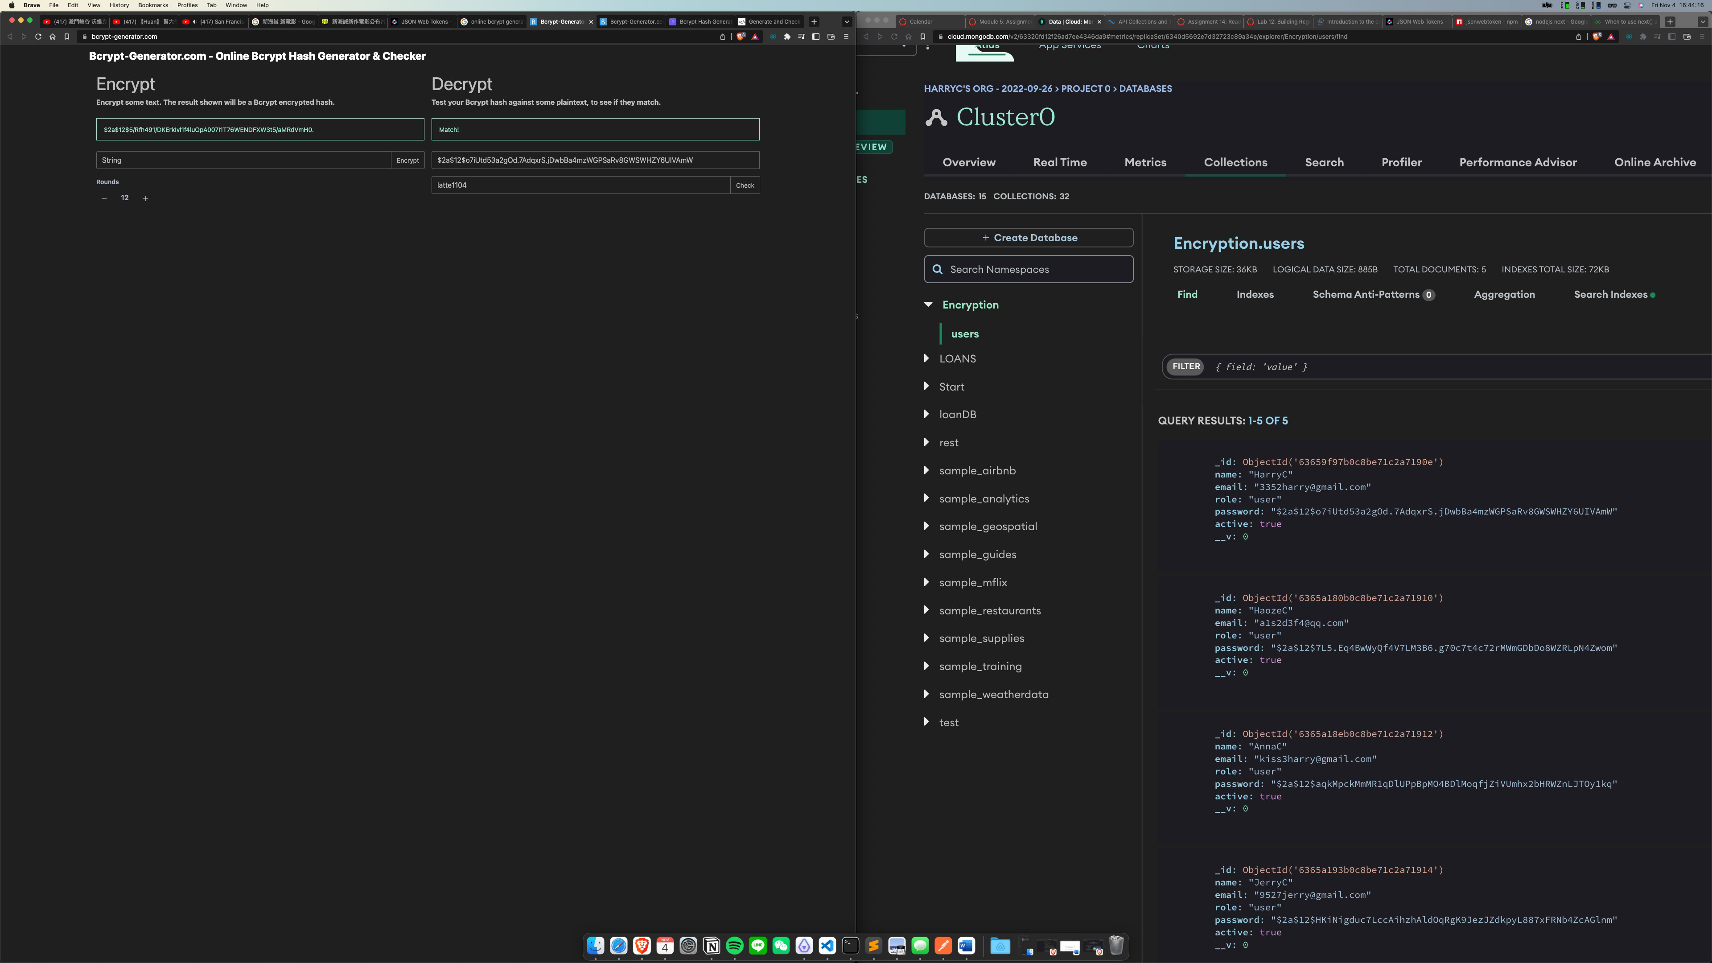

* Config.env

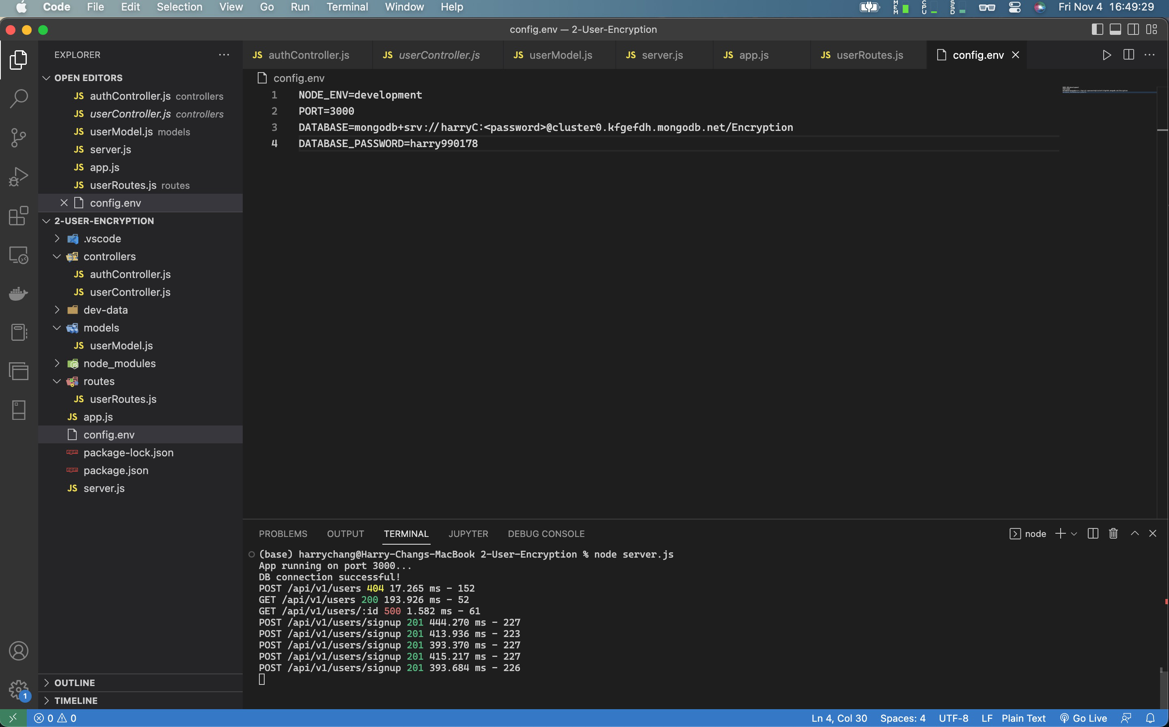

**Project: 3-User-JWT**

* Tokenize user._id

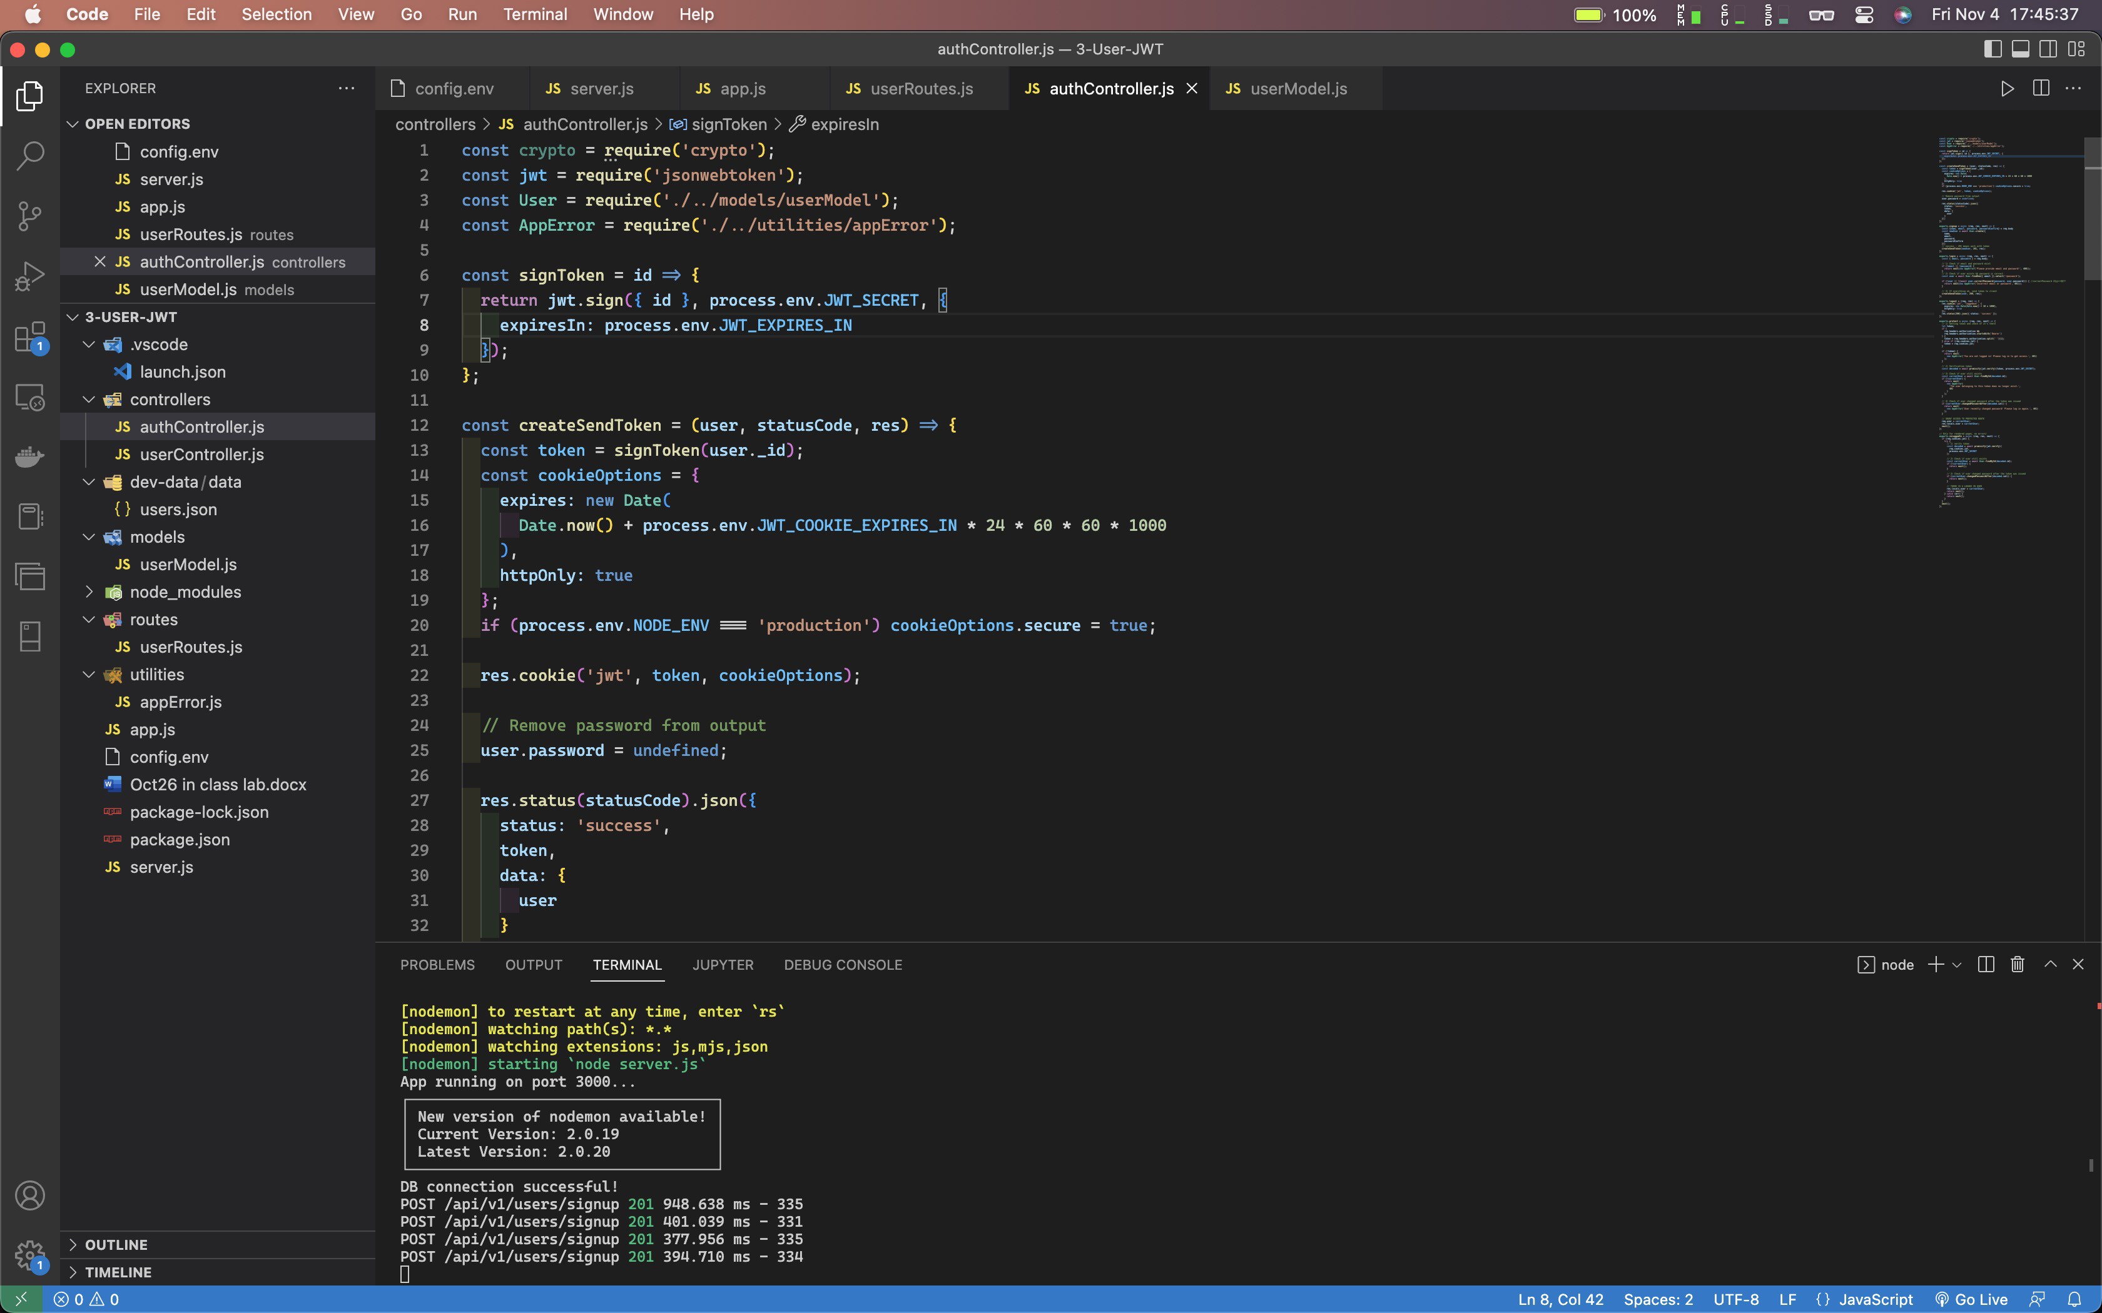

* Created 5 users with token

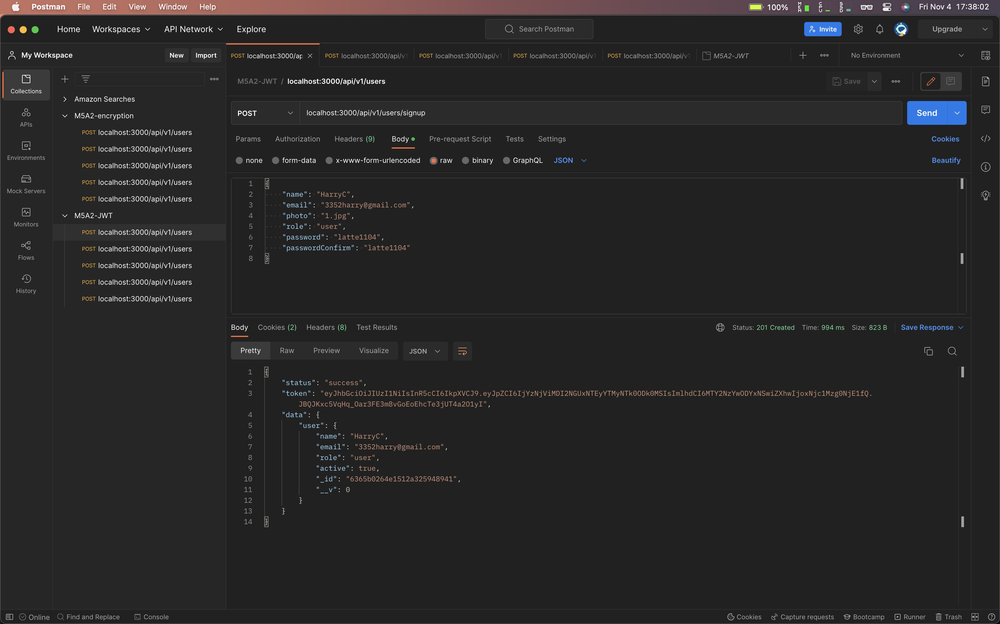

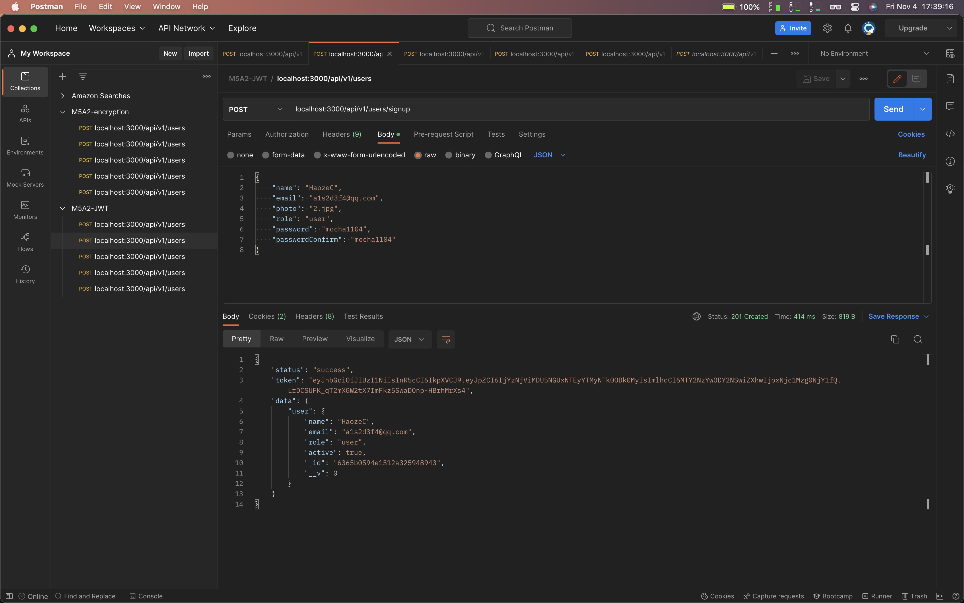

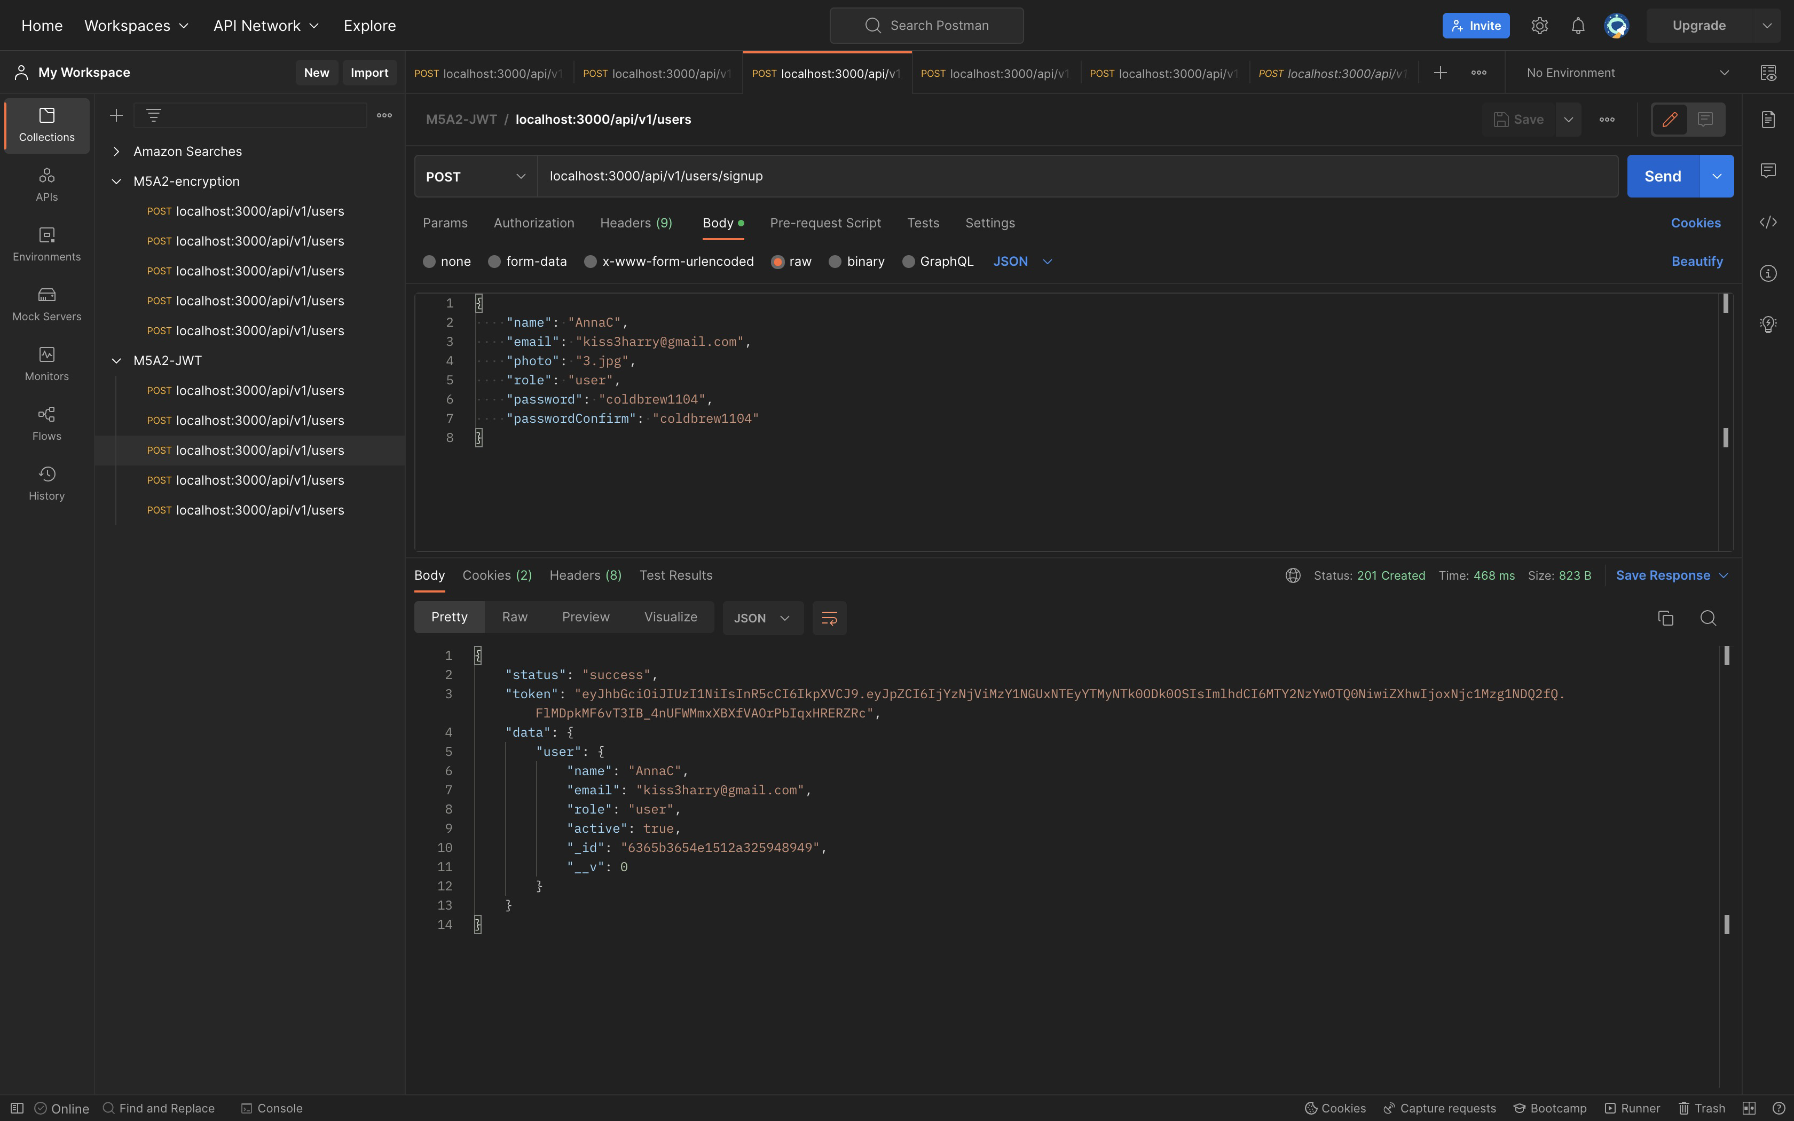

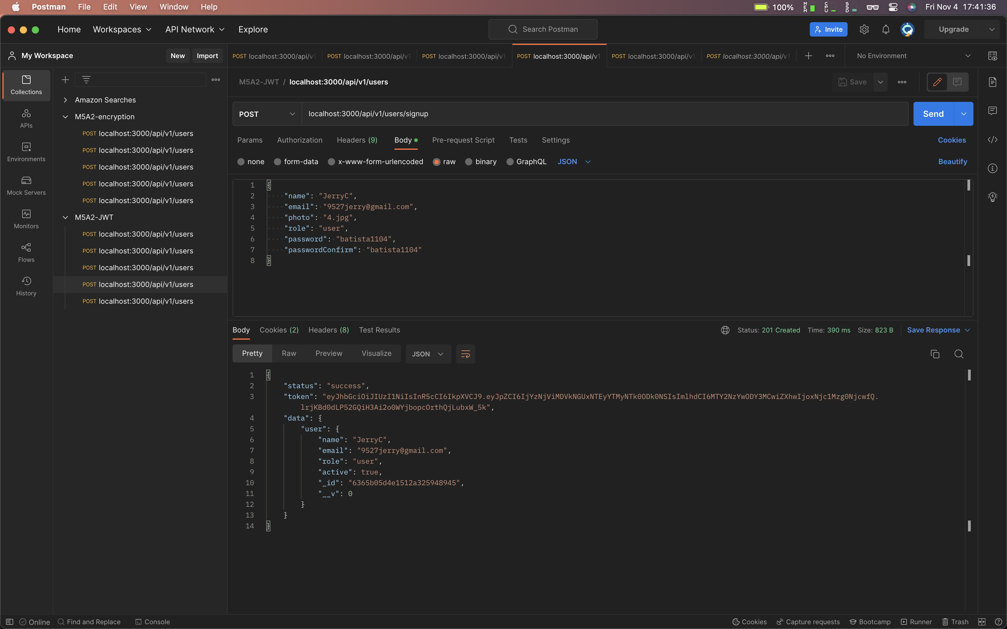

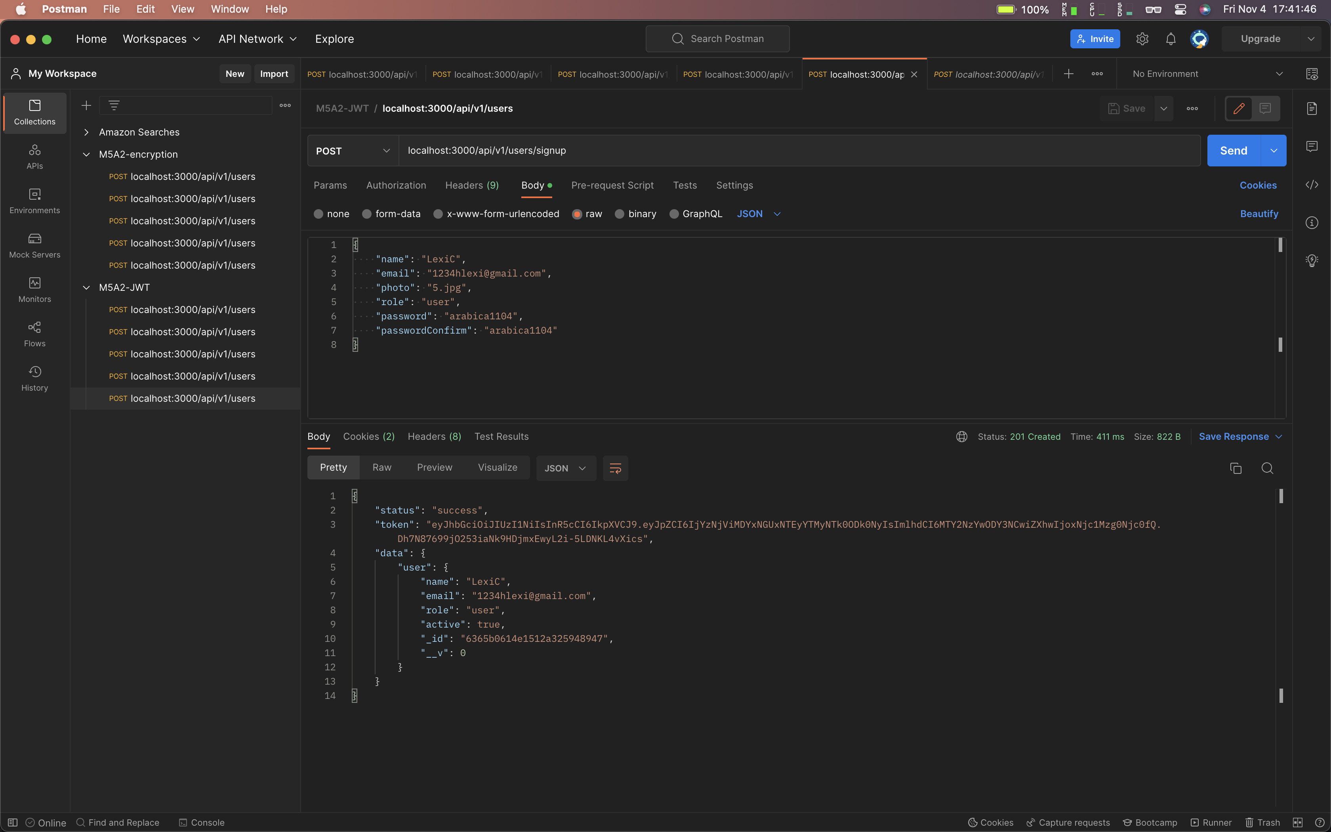

Decode token and payload will output “_id”

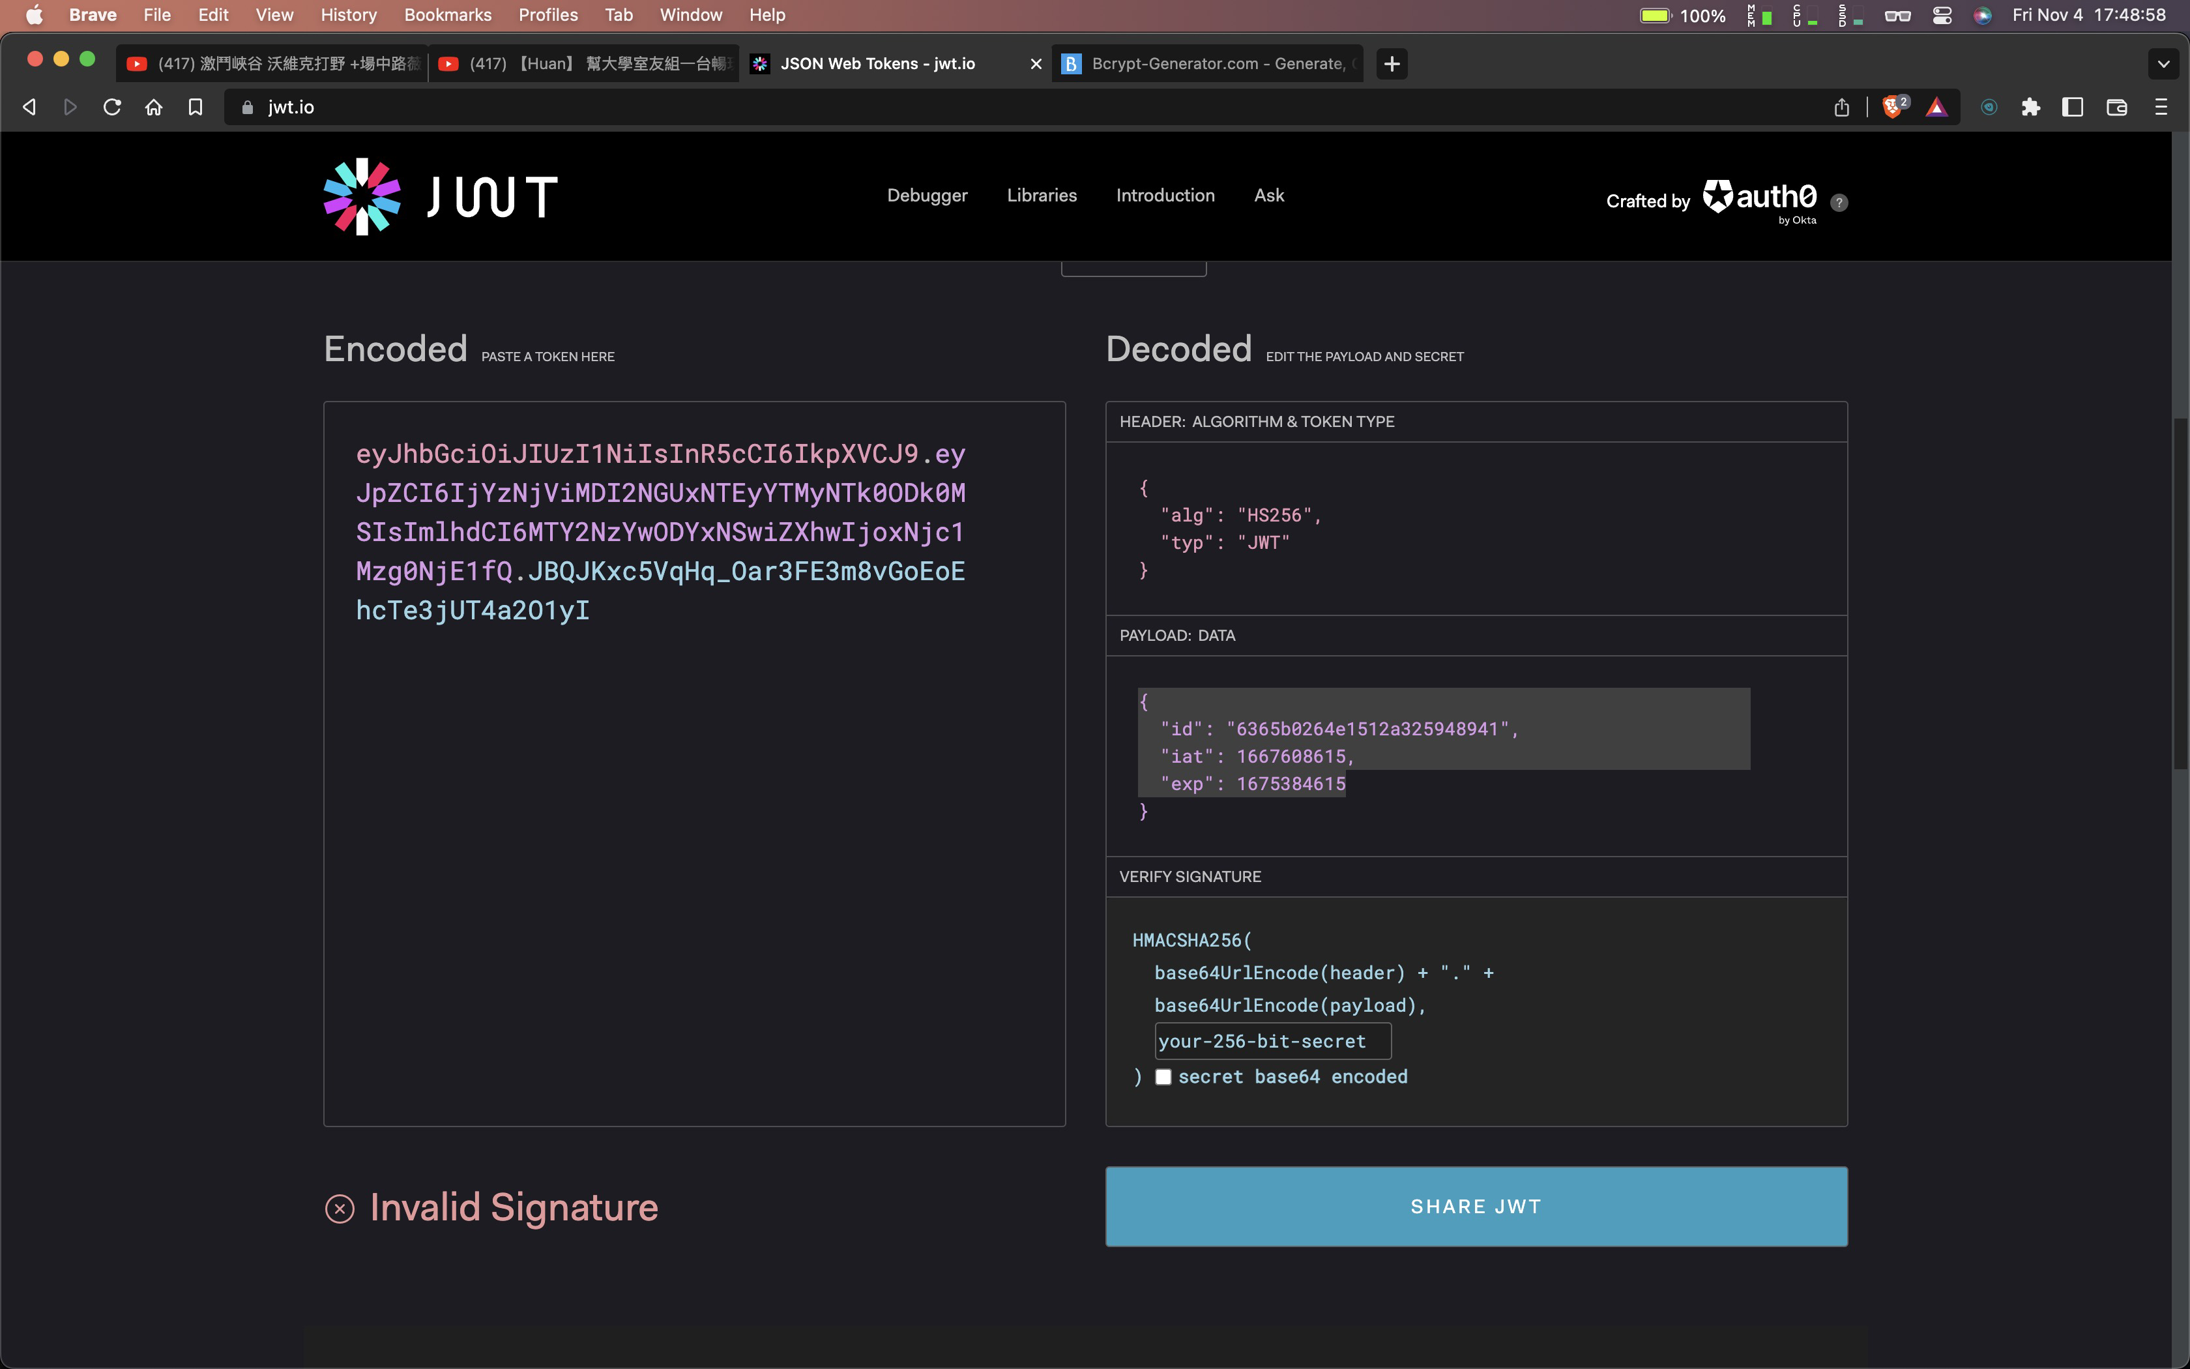

* MongoDB

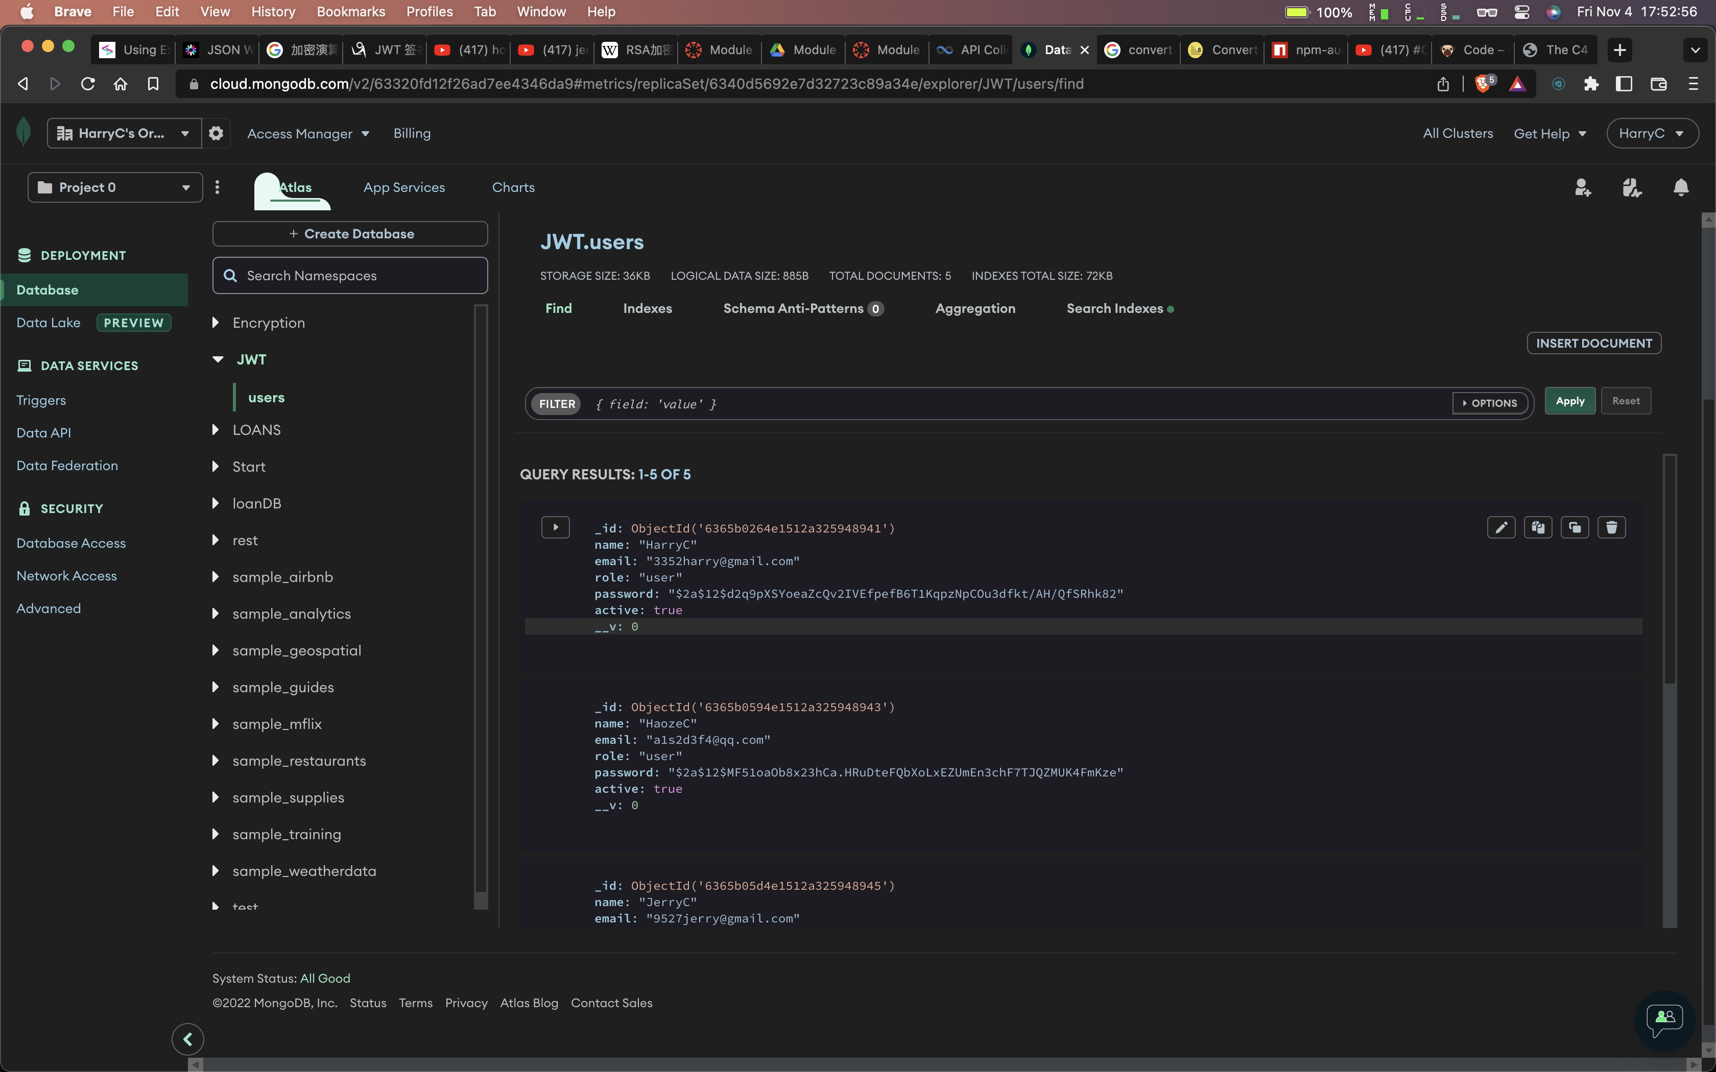

* If I tokenize the user

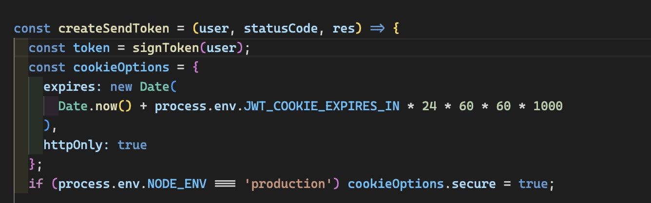

* Decode the token will get the whole user data with encrypted password

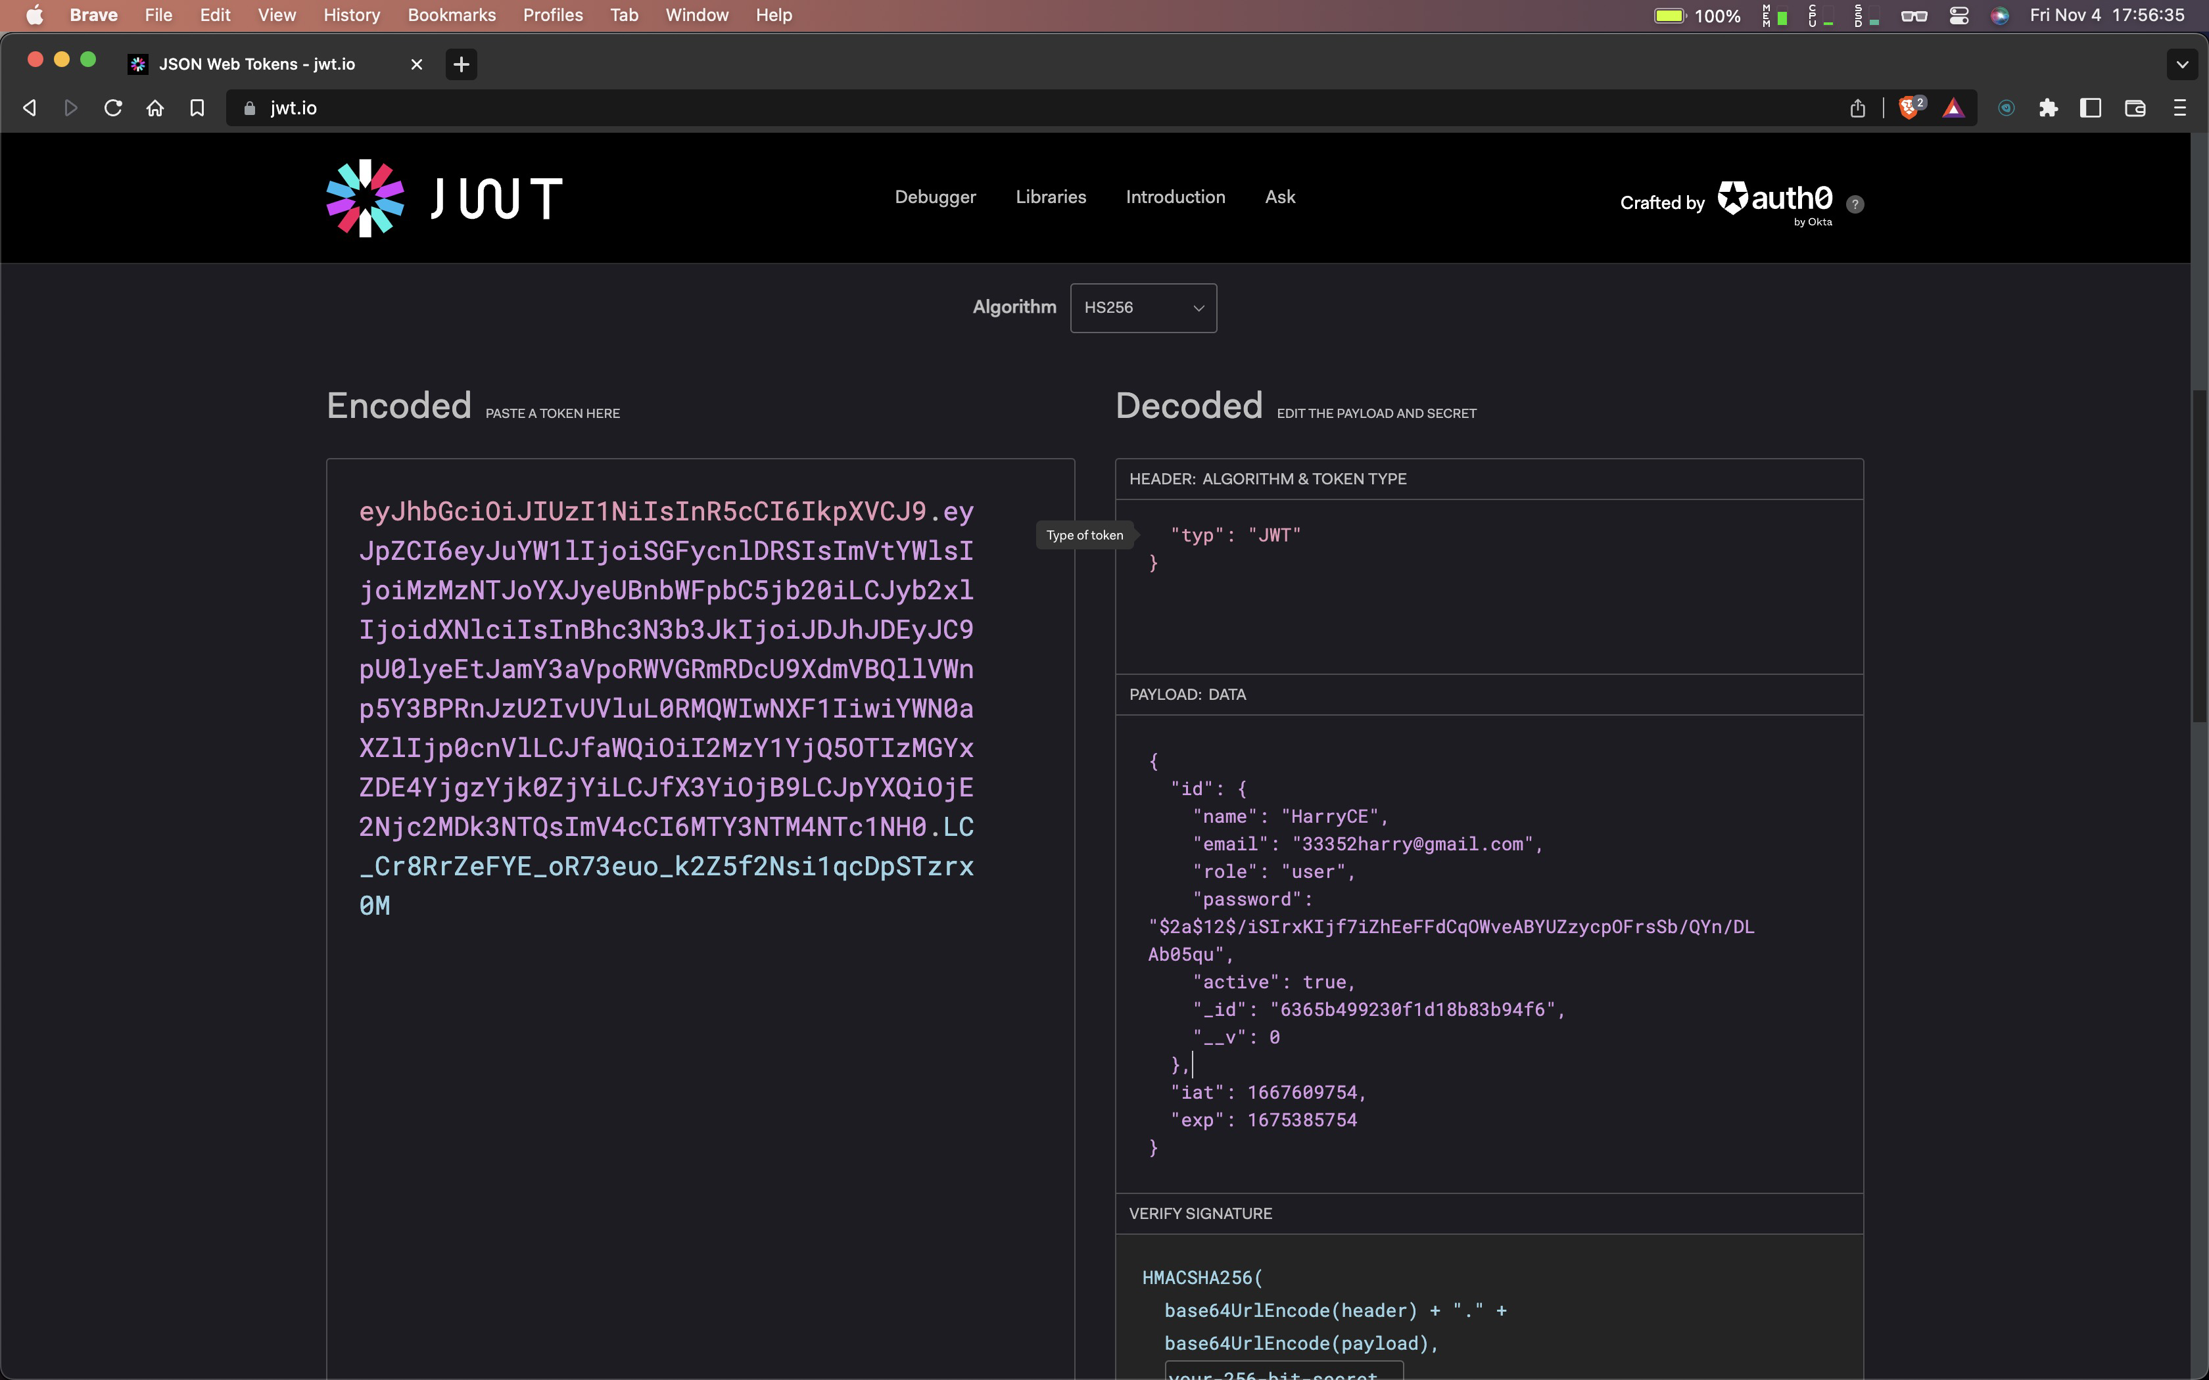

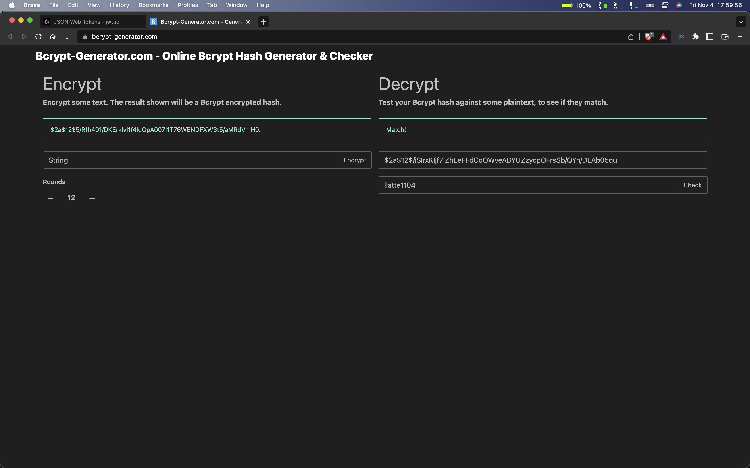

/auth

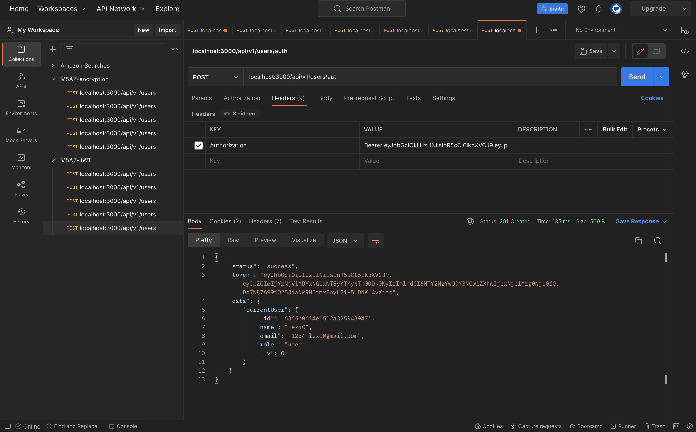

* Brief of JWT

JSON Web Token is a proposed Internet standard for creating data with optional signature and/or optional encryption whose payload holds JSON that asserts some number of claims. The tokens are signed either using a private secret or a public/private key.

JWT relies on other JSON-based standards: JSON Web Signature and JSON Web Encryption.

